function dragPaddle(e)

if(e.phase == "began") then--板子的初始位置

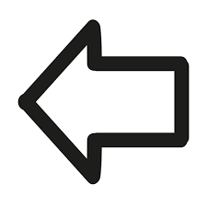lastX = e.x - paddle.x--板子只有左右移動,只改變 x 值



elseif(e.phase == "moved") then--板子移動中的位置

paddle.x = e.x – lastX

end

end 應日3A 0432003 吳柏賢

local background = display.newImage( "back.jpg")

background.x = display.contentCenterX

background.y = display.contentCenterY

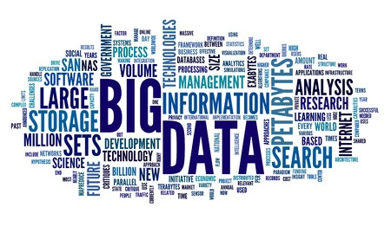

local background2 = display.newImage( "pole.jpg")

background2.x = display.contentCenterX

background2.y = display.contentCenterY -50

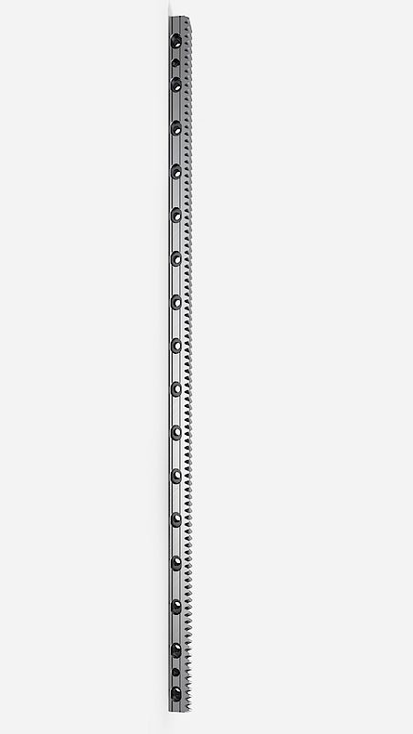

local ball = display.newImage( "pole.jpg")

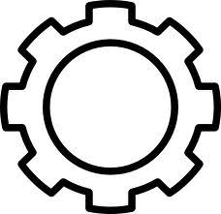

ball.x = display.contentCenterX -200

ball.y = display.contentCenterY +100

  local backgroundMusic = audio.loadStream( "JP.mp3" )

audio.play(backgroundMusic,{ channel=1, loops=-1 })

audio.setVolume( 0.8 , {channel=1})

<https://www.youtube.com/watch?v=owC66LIBObg> (音樂)

local ground1 = display.newImage( "ground1.jpg")

ground1.x = display.contentCenterX-250

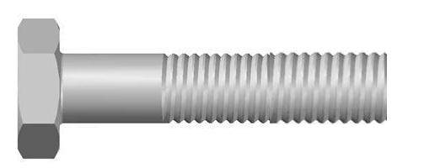

ground1.y = display.contentCenterY -100

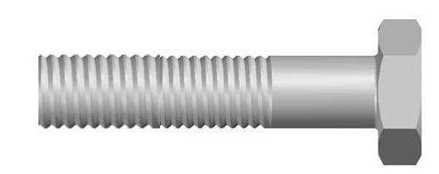

local ground2 = display.newImage( "ground2.jpg")

ground2.x = display.contentCenterX+250

ground2.y = display.contentCenterY -100

if event.other.type == "ball" == "ground1" then

Total1 = Total1 + 1

ScoreText1 = Total1

if event.other.type == "ball" == "ground2" then

Total2 = Total2 + 1

ScoreText2 = Total2

Elseif Total1 = 10 or Total2=10 then

gameState ="Gameover"

restartGame(gameState)

end

end -----計分

機械3A 0414040 楊燿銘